Ideation Phase
Empathize s Discover
Date 30 June 2025
Team ID LTVIP2025TMID49757
Project Name Visualization Tool For Electric Vehicle Charge And Range Analysis
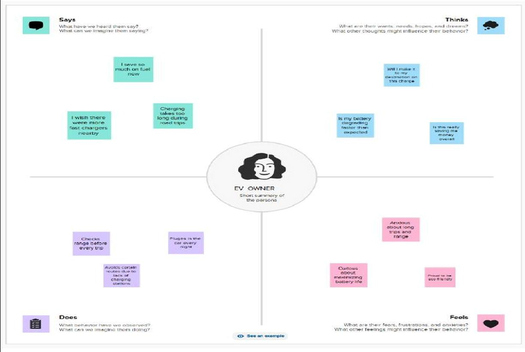
Maximum Marks 4 Marks
Empathy Map Canvas:
An empathy map is a simple, easy-to-digest visual that captures knowledge about a user’s behaviours and attitudes.
It is a useful tool to helps teams better understand their users.
Creating an effective solution requires understanding the true problem and the person who is experiencing it. The exercise of creating the map helps participants consider things from the user’s perspective along with his or her goals and challenges.
Reference: https://www.mural.co/templates/empathy-map-canvas
Example: Food Ordering s Delivery Application
